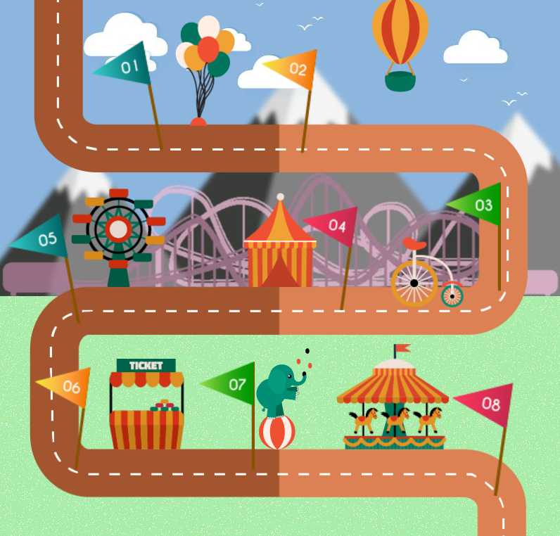 | X YZ  Group Plan  2019 to 2021

Our Mission & Vision
The Mission of Scouts Australia is to contribute to the education of young people, through a value system based on the Scout Promise and Law, to help build a better world where people are self-fulfilled as individuals and play a constructive role in society.

The Vision of Scouts Australia is to be seen as the pre-eminent youth organisation in Australia. We engage and inspire young Australians to develop confidence, resilience and leadership.

We achieve this by:

- Involving young people throughout their formative years in a non-formal educational process
- Using a specific method that makes each individual the principal agent in their own development as a self-reliant, supportive, responsible and committed person
- Assisting them to establish a value system based on spiritual, social, and personal principles as expressed through the Scout Promise and Law.

Scout Law  A Scout is trustworthy.  A Scout is loyal.  A Scout is helpful.  A Scout is friendly.  A Scout is cheerful.  A Scout is considerate.  A Scout is thrifty.  A Scout is courageous.  A Scout is respectful.  A Scout cares for the environment. | Scout Promise  On my honour  I promise that  I will do my best  To do my duty to my God  And to Australia  To help other people and  To live by the Scout Law.

Our Group
XYZ Scout Group strategy is to resource the group to be able to provide a range of unique activities that will attract and retain local children and young people to support their development through the Scouting movement.

The aim of the Youth Programme plan is;
- Xxx
- Xxx
- xxx

The aim of the Member plan is;
- Retain & Grow Youth membership
- Retain & Grow Leader membership
- Retain & Grow Parent participation
- xxx

The aim of the Asset Management plan is;
- Xxx
- Xxx
- xxx

The aim of the Sustainable Funding plan is;
  - Fundraising through local opportunities
  - Grant submissions
  - Corporate donations

Programming Plan
Programming Plan
Where are we now? |  | xxx
Where do we want to be by 2019? |  | xxx
How will we know we’re there? |  | xxx
What do we need to do? |  | xx |  | xx |  | xx |  | xx
How will we do it? |  | xx |  | xx |  | xx |  | xx

Youth Membership
Youth Membership Plan
Where are we now?
Where do we want to be by 2019? |  | Minimum 18 per Youth Section
How will we know we’re there?
What do we need to do? |  | Youth Programming |  | Youth Recruitment |  | Youth Linking |  | Regular Parent Communications
How will we do it? |  | Open activities for non-scout youth |  | Regular advertising through local schools  Advertising of scout achievements in the local paper  Advertise in local paper  Have articles about activities  Have venturers write articles for submission? |  |  |  | E.g. functions, news bulletins, etc.

Leader Membership Plan
Leader Membership Plan
Where are we now?
Where do we want to be by 2019? |  | Sufficient Leaders
How will we know we’re there?
What do we need to do? |  | Leader Retention |  | Leader Recruitment |  | Leader Training |  | Effective Group Councils
How will we do it? |  |  |  |  |  | e.g. working towards the Wood badge)

Parent Support
Parent Support Plan
Where are we now? |  | Location:
Where do we want to be by 2019?
How will we know we’re there?
What do we need to do? |  |  |  |  |  |  |  | Effective Group Committee
How will we do it?

Funding
Sustainable Funding Plan
Where are we now?
Where do we want to be by 2019?
How will we know we’re there?
What do we need to do?
How will we do it?

Asset Management
Hall Plan
Where are we now? |  | Location:
Where do we want to be by 2019?
How will we know we’re there?
What do we need to do?
How will we do it?

Asset Management
Equipment Plan
Where are we now? |  | xxxx
Where do we want to be by 2019?
How will we know we’re there?
What do we need to do?
How will we do it?

