Distress Beacon Information and Registration Website Guidance
How do I check my beacon registration status online?
Step 1:
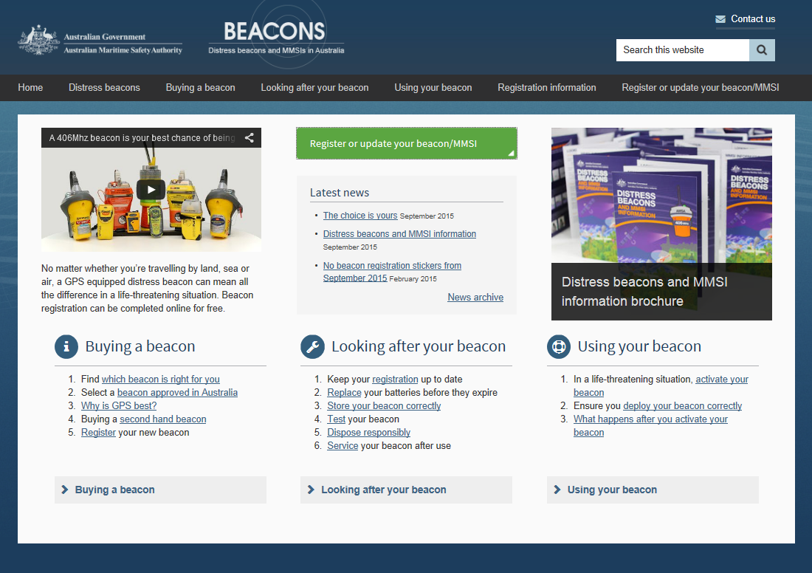Go to the following website address: www.amsa.gov.au/beacons and select the green button that says ‘Register or update your beacon/MMSI’.

Step 2:
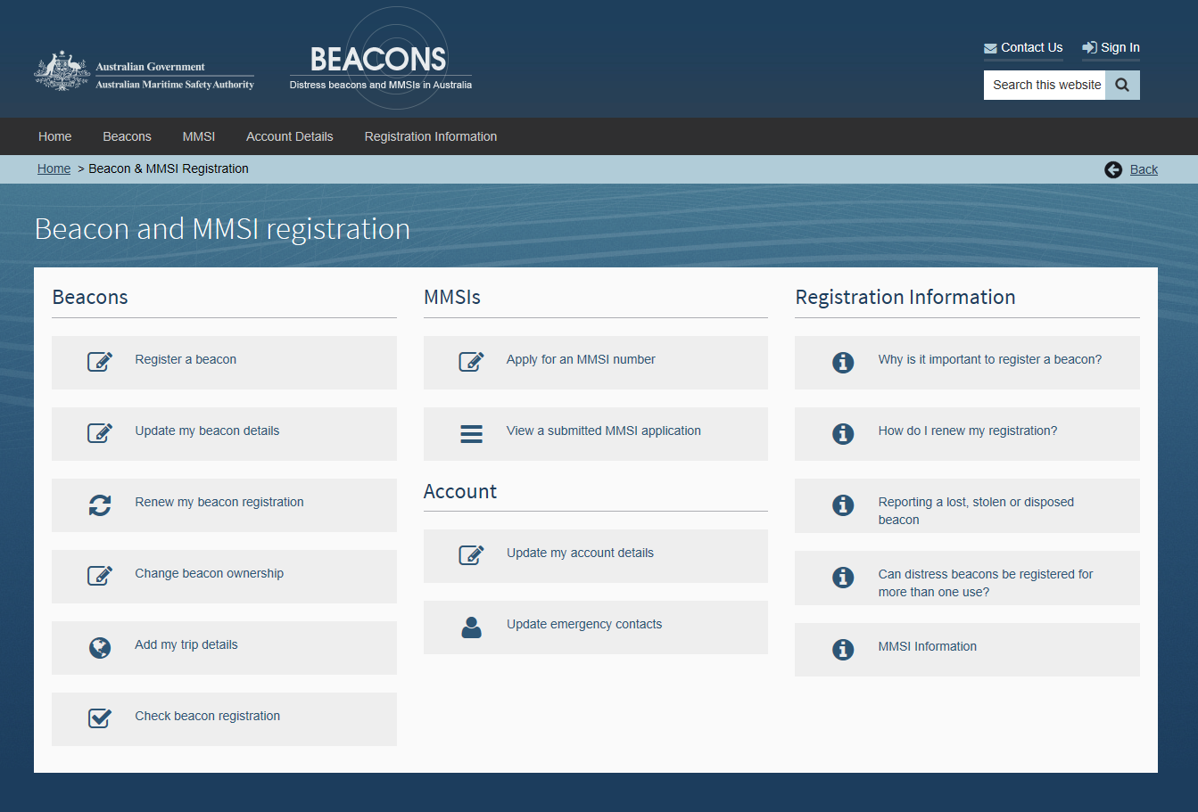Once the following page should loads, click on the button that says ‘Check my beacon registration’ (as indicated by the red circle below).

Step 3:
Step 3:
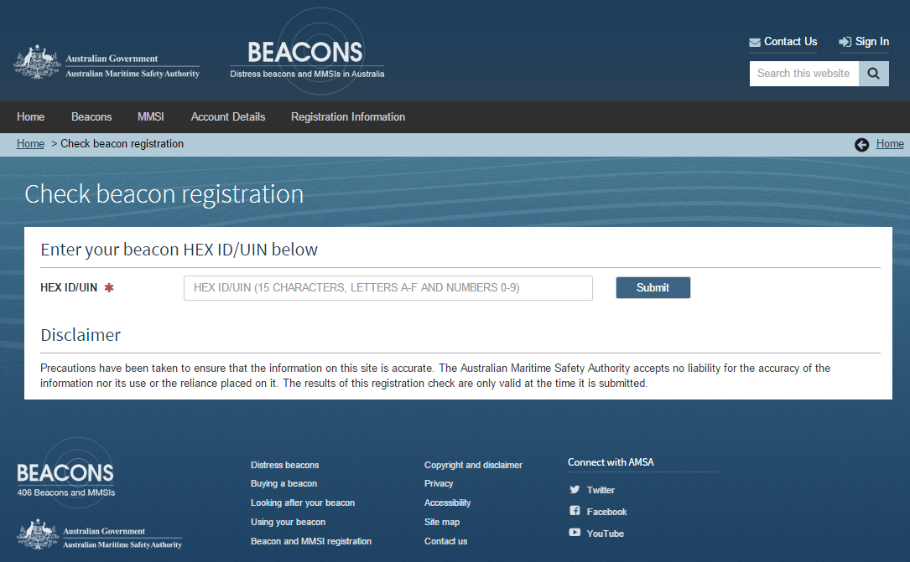Once the following page has loaded, enter your 15 digit HED ID/UIN in the space indicated below and press submit.
Enter your 15 digit HEX ID/UIN code here

What is a HEX ID or UIN code?
The Hex ID or Unique Identification Number (UIN) is the unique code programmed into each 406 MHz distress beacon. When registering a distress beacon, this code must be provided as it is the only code that links the distress beacon to the registered owner. Without the Hex ID the beacon cannot be registered.
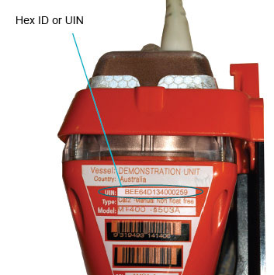The Hex ID is 15 characters long and is made up of hexadecimal numbers (0-9) and letters (A-F). The Hex ID can be found on the label of all 406 MHz distress beacons

Step 4:
The next 3 messages may pop up, depending on the status of your beacon:
- Example message display if your beacon is currently registered
- 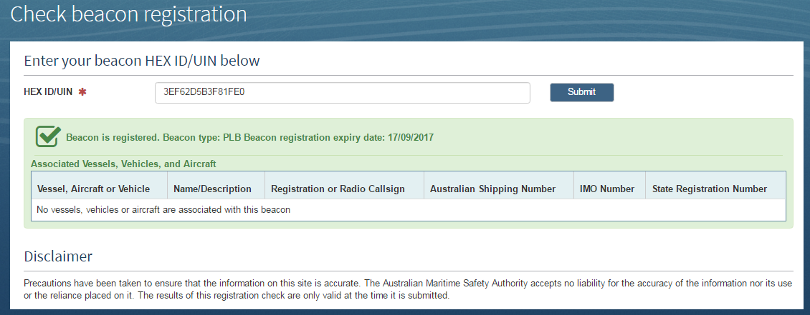Example message display if your beacon is not registered:

Possible reasons for this message – The beacon status has been recorded as disposed, sold, re-programmed, exchanged, registration has expired.
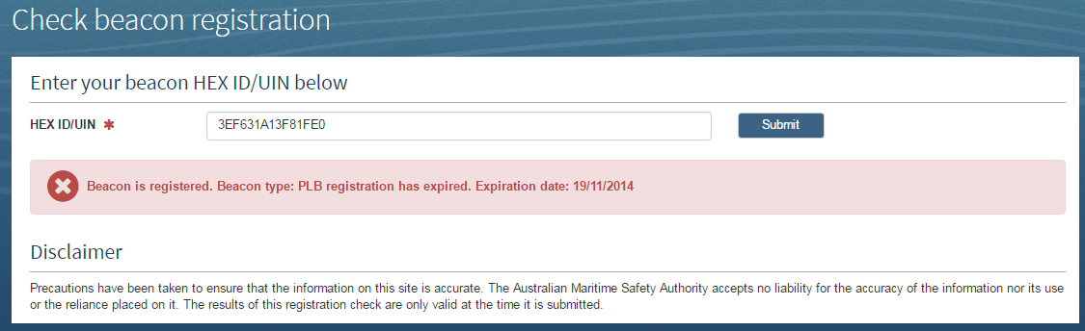
- Example message display if you need to contact AMSA for further assistance in relation to your beacon registration:

Possible reasons for message – Incomplete beacon registration, duplicate HEX ID, other.


